Assignment 6

DSP for Computer Science

- 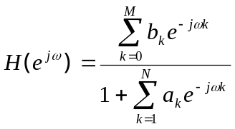Write a program in MATLAB or any other software of your choice to compute the DTFT of a difference equation given the coefficients.

- Coefficient Quantization: This exercise is taken from the following link: http://cnx.org/content/m10813/latest/. First compute the notch Butterworth filter in MATLAB using the following command:
>>[b,a] = butter(2,[0.07 0.10],'stop').
Then plot its frequency response (DTFT, magnitude and phase). Next, do a 16 bit quantization of the filter coefficients (excluding the first coefficient of array a, which has a value of 1). The approximate procedure has been described in above link but you are free to use any other equivalent/more accurate procedure. Compute the DTFT for this approximation. Compare the two DTFTs. Now implement the cascade form by factoring the numerator and denominator into second order structures and then quantize them to 16 bits. Compute the resulting DTFTs. The overall DTFT is the product of the DTFTs of the two cascade sections. Compare the response to the original response. What difference do you see from direct form response? Note that to compare the DTFT magnitude responses, you may have to normalize them. This is done by dividing each magnitude response by its maximum. For full credit, show all the plots-both magnitude and phase.

